**IT 4983 Capstone Career Profile Assignment Guide**

By Jack Zheng

Last updated on Sept 15, 2016

## Overview

As part of the capstone project course, you will create a professional profile and career portfolio that will add value to your profession. We are using the LinkedIn platform to help you build your profile and network.

* What is LinkedIn? <https://www.youtube.com/watch?v=ZVlUwwgOfKw>
* LinkedIn for Students: Your Career Starts Here: <http://students.linkedin.com>

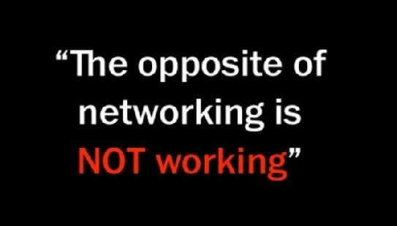Why do students need to know and use LinkedIn?

* <http://www.dazeinfo.com/2013/02/26/social-media-channels-used-by-recruiters/>
* <http://www.ere.net/2012/07/02/20-reasons-why-linkedin-will-be-the-1-recruiting-portal-of-the-future/>
* <http://www.emergingedtech.com/2011/03/11-reasons-why-every-college-student-needs-a-linkedin-page/>
* <http://money.usnews.com/money/blogs/outside-voices-careers/2011/05/11/why-college-students-should-join-linkedin>

## Instructions

Visit LinkedIn (<http://www.linkedin.com>) and create an account. Use the system to create a profile by adding various components. Here are some tutorials and tips to get you started:

* <http://university.linkedin.com/linkedin-for-students.html>
* <http://mashable.com/2011/08/09/linkedin-profile-job-search/>
* <http://jobsearch.about.com/od/networking/a/linkedinprofile.htm>
* <http://blog.hubspot.com/blog/tabid/6307/bid/23454/The-Ultimate-Cheat-Sheet-for-Mastering-LinkedIn.aspx>

### Requirements

Please build following sections (requirement details included) in LinkedIn. The **first 5 items are required**.

1. **Summary: use a concise paragraph to describe yourself professionally including your career goals.**
2. **Connections: add at least 20 connections. You are welcome to connect with the instructor.**
3. **Skills & Expertise: list at least 5 IT related skills and get at least two endorsements total.**
4. **Education: complete your educational profile.**
5. **Projects: list at least 2 projects with descriptions or links (class or work projects – add the capstone).**
6. Experience: add at least 1 work experience.
7. Groups: join at least three groups (don’t forget the “KSU/SPSU IT Department” group <http://www.linkedin.com/groups?gid=4673332>). Start or reply to a discussion.
8. Courses: list at least 5 IT major courses you have taken.
9. Photo: use a professional photo.
10. Honors and Awards: add at least 1 item.
11. Volunteer Experience & Causes: add at least 1 experience.
12. Certifications: add at least 1 item.
13. Recommendations: have at least 1 decent recommendation.
14. Customize your profile URL to something like <https://www.linkedin.com/in/jgzheng>.
15. Follow an industry leader/influencer.

### Sample profiles of previous capstone students (you may need to login to view full profile)

* <http://www.linkedin.com/in/michaeldavisit>
* <https://www.linkedin.com/in/ydagnoko>
* <http://www.linkedin.com/in/jamarsalmon>
* <http://www.linkedin.com/in/dgould1>
* <https://www.linkedin.com/in/ritchierthomas>
* <https://www.linkedin.com/in/rebekahchang92>
* <http://www.linkedin.com/pub/david-phifer/3a/a08/187>
* <https://www.linkedin.com/in/jean-francois-locko-46075a88>
* Join the “KSU/SPSU IT Department” group <http://www.linkedin.com/groups?gid=4673332> to view more people.

## Submission

Export your profile to **PDF** (see the screenshot below) and submit it to D2L. Do NOT hide any part of your profile until the end of the semester (or until you see a grade). Then, please review and adjust your privacy controls here <https://www.linkedin.com/settings/?trk=nav_account_sub_nav_settings>

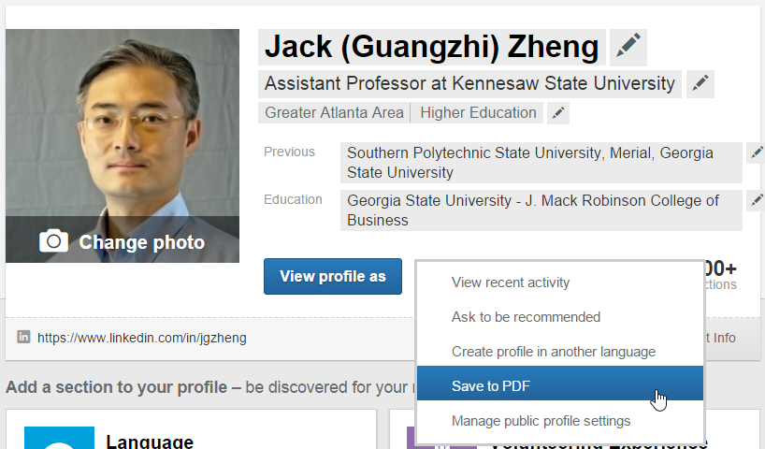

Or in the new UI:

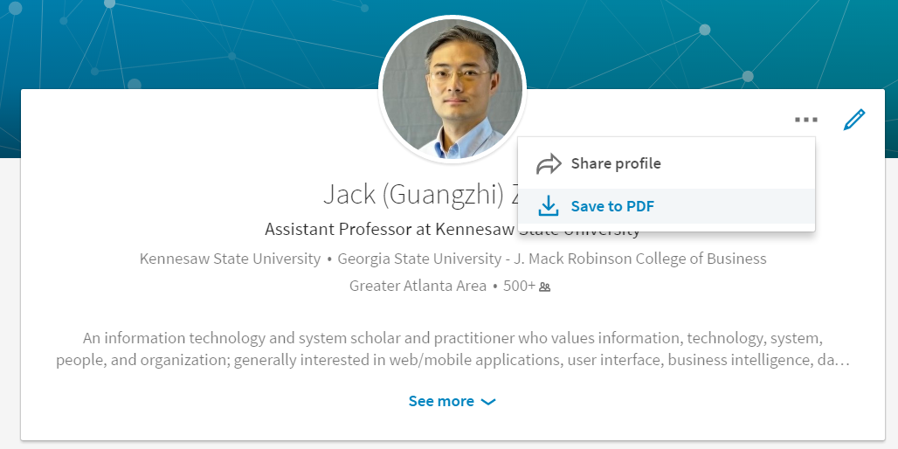

## Grading

|  |  |
| --- | --- |
| **Grade** | **Explanation** |
| 10 | The profile is perfect satisfying all requirements and followed the submission requirement. |
| 9 | Misses some optional profile items but has all required profile items. |
| 8 | Misses some required and optional profile items. |
| 6-7 | Misses major required profile items. |
| <5 | Incomplete and lack of quality description. Failed to follow the submission requirement. |

## Common issues and mistakes

1. **“Unfortunately, I made the mistake of believing that I didn't need too much time to finish this assignment. I realized after starting it that it takes a long time for people to accept your connection requests, group requests, recommend you, and endorse you.”**
2. Unprofessional photo.
3. Weak summary – summary should be concise and at a high level. You may put career goals here. Again, be concise.
4. Too much irrelevant details. For example, don’t put too many junior courses (such as Hardware and Software, Intro to Programming, etc.) there.
5. Do you put experience not relevant to your career goal, like Truck Driver, Cashier at Chick Fila, Bartender, etc.? Well, there is no simple answer but try to think from your audience’s perspective.

## More tips

* Top 10 Overused LinkedIn Profile Buzzwords: <http://blog.linkedin.com/2013/12/11/buzzwords-2013/>
* <http://www.linkedin.com/today/post/article/20130117141235-20017018-stop-using-these-16-terms-to-describe-yourself>
* <http://www.linkedin.com/today/post/article/20121206081322-8353952-the-1-career-mistake-capable-people-make>

## Other references and resources

* Career profile and portfolio: <http://www.ccd.me.edu/careerprep/>